**Ideation Phase**

**Brainstorm & Idea Prioritization Template**

|  |  |
| --- | --- |
| Date | 22nd May 2025 |
| Team ID | LTVIP2025TMID53284 |
| Project Name | learn hub-Your center for skill enhancement |
| Maximum Marks | 4 Marks |

**Brainstorm & Idea Prioritization Template:**

**Step-1: Team Gathering, Collaboration and Select the Problem Statement**

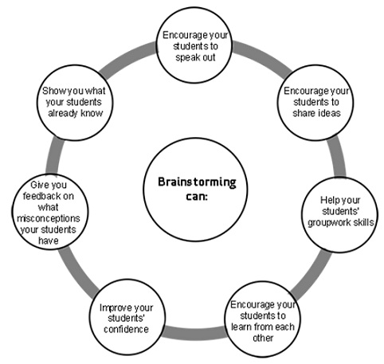

**Step-2: Brainstorm, Idea Listing and Grouping**

**Generate Ideas in Focused Rounds**

**Use time-boxed sprints around specific LearnHub aspects:**

**🔹 Round 1: Engagement Features**

**How could we make learners excited to log in every day?**

**Examples: progress streaks, daily mini-quizzes, personalized learning paths.**

**🔹 Round 2: Social & Community**

**How could LearnHub help learners support each other?**

**Examples: group projects, “study buddy” matching, community challenges.**

**🔹 Round 3: Certification & Recognition**

**How can we make LearnHub certificates more meaningful?**

**Examples: badges endorsed by employers, shareable achievements on LinkedIn.**

**🔹 Round 4: Accessibility & Inclusion**

**How can LearnHub be more inclusive?**

**Examples: multilingual course content, screen-reader compatibility, adjustable UI themes.**

**🔹 Round 5: Marketing & Growth**

**How could LearnHub reach more people?Examples: referral rewards, partnerships with influencers, ambassador programs**

Cluster and Organize LearnHub Ideas

After generating ideas, categorize them into themes like:

1.Gamification ideas

2.Social features

3.Certification upgrades

4.Marketing strategies

Evaluate & Prioritize

Discuss each idea’s:

* Impact on learners (will it improve engagement, outcomes, or satisfaction?)
* Feasibility (can we implement it with our current resources?)

✅ Use a Feasibility vs. Impact matrix to quickly see which ideas to act on first.

**Step-3: Idea Prioritization**

Choose promising ideas to prototype or research further.

Examples:

1. “Daily XP and rewards for consistent course progress.”
2. “Live virtual ‘office hours’ with instructors.”
3. “Certification badges verified by industry partners.”

📌 Example Brainstorm Outputs:

* Add gamified progress bars and daily login streaks.
* Create interactive group projects for learners.
* Introduce mentorship programs linking learners with experts.
* Offer certificates with optional employer endorsements.
* Launch a referral program giving free premium access for inviting friends.